3rd Conservation and Restoration Conference of the Croatian Conservation Society
ConRestCon 2024
Zagreb
September 2024

APPLICATION FORM

The deadline for submitting the Application Form is June 15, 2024.

Send applications forms in .doc/.docx format!

PRESENTATION TITLE*:
*Each presentation requires a separate application form
METHOD OF PRESENTATION:
Oral presentation (10 - 15 minutes)
Poster presentation
Video presentation (2 - 10 minutes)

AUTHOR 1 | Name
AUTHOR 1 | Profession:
AUTHOR 1 | Place of work:
AUTHOR 1 | Establishment:
AUTHOR 1 | Address:
AUTHOR 1 | Phone number
AUTHOR 1 | E-mail:

AUTHOR 2 | Name
AUTHOR 2 | Profession:
AUTHOR 2 | Place of work:
AUTHOR 2 | Establishment:
AUTHOR 2 | Address:
AUTHOR 2 | Phone number
AUTHOR 2 | E-mail:

AUTHOR 3 | Name
AUTHOR 3 | Profession:
AUTHOR 3 | Place of work:
AUTHOR 3 | Establishment:
AUTHOR 3 | Address:
AUTHOR 3 | Phone number
AUTHOR 3 | E-mail:

ABSTRACT (200 words max):
WORK PHOTO (1 photo in .jpeg format):

Send applications forms in .doc/.docx format!
3rd Conservation and Restoration Conference of the Croatian Conservation Society
ConRestCon 2024
Zagreb
September 2024

MEDIA RELEASE CONSENT FORM

I hereby consent to the processing and publication, in whole or in part, of my personal data as well as the presentation, poster, or video presentation and their parts, and photographs that I submit for ConRestCon 2024 organized by the Croatian Conservation-Restoration Association (HRD) and the Croatian State Archives (HAD) in the year 2024, on the official website of HRD and HDA, as well as on HRD's and HDA's social media profiles.

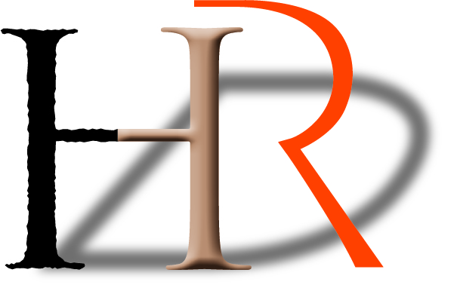
Signature

